

How to Have a Sane Divorce

Stop the Pain for everyone involved. Use a Divorce Coach.
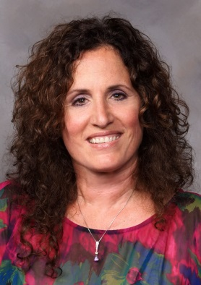
I am Dr. Laura DeMarzo, psychologist and certified divorce coach. With decades of counseling experience dealing with families and marriages in conflict, I will work collaboratively and respectfully with the parties resulting in resolution of your issues. I can help.

“How do I know if I need a Divorce Coach?”
- You have trouble sleeping because you can't get the rage or hurt out of your mind.
- You want to minimize the damage on the children’s lives.
- You are having difficulty addressing your spouse in constructive ways.
- When you see your spouse's caller id on your phone you feel as if you got punched in the stomach.

“What is a Divorce Coach? “
- A Psychologist or Mental Health Professional certified in mediation and collaborative divorce working in partnership with the parties to achieve desired outcomes.
- A Divorce Coach enables the client to deal and cope with the strong emotions that may get in the way of good decision-making.
- Works collaboratively with all parties including attorneys/mediators.
- Goals are established, facilitated and achieved in a professional and respectful manner.
- As your divorce coach, I will guide you, step by step, through the rocky waters of separation and divorce - which can save you time, money and emotional pain.

As your Divorce Coach I will help you to:
- Minimize negative effects upon your family and children.
- Learn skills to overcome obstacles.
- Focus on desired outcomes.
- Establish “your voice” in the process of resolution.
- Accomplish your goals of living peacefully and moving forward with a positive attitude rather than dwell or rehash the past.
- Understand that strong emotions are a normal part of the process, and I will teach you how to better cope.
- Avoid escalating legal fees, which occur when your emotions get in the way of resolution.
Call Dr. Laura DeMarzo, Ed.D. Psychologist, Certified Divorce Coach (908) 431-9200 or Cell (908) 642-0258 491 Amwell Road Suite 103, Hillsborough NJ 08844
www.sanedivorce.net

